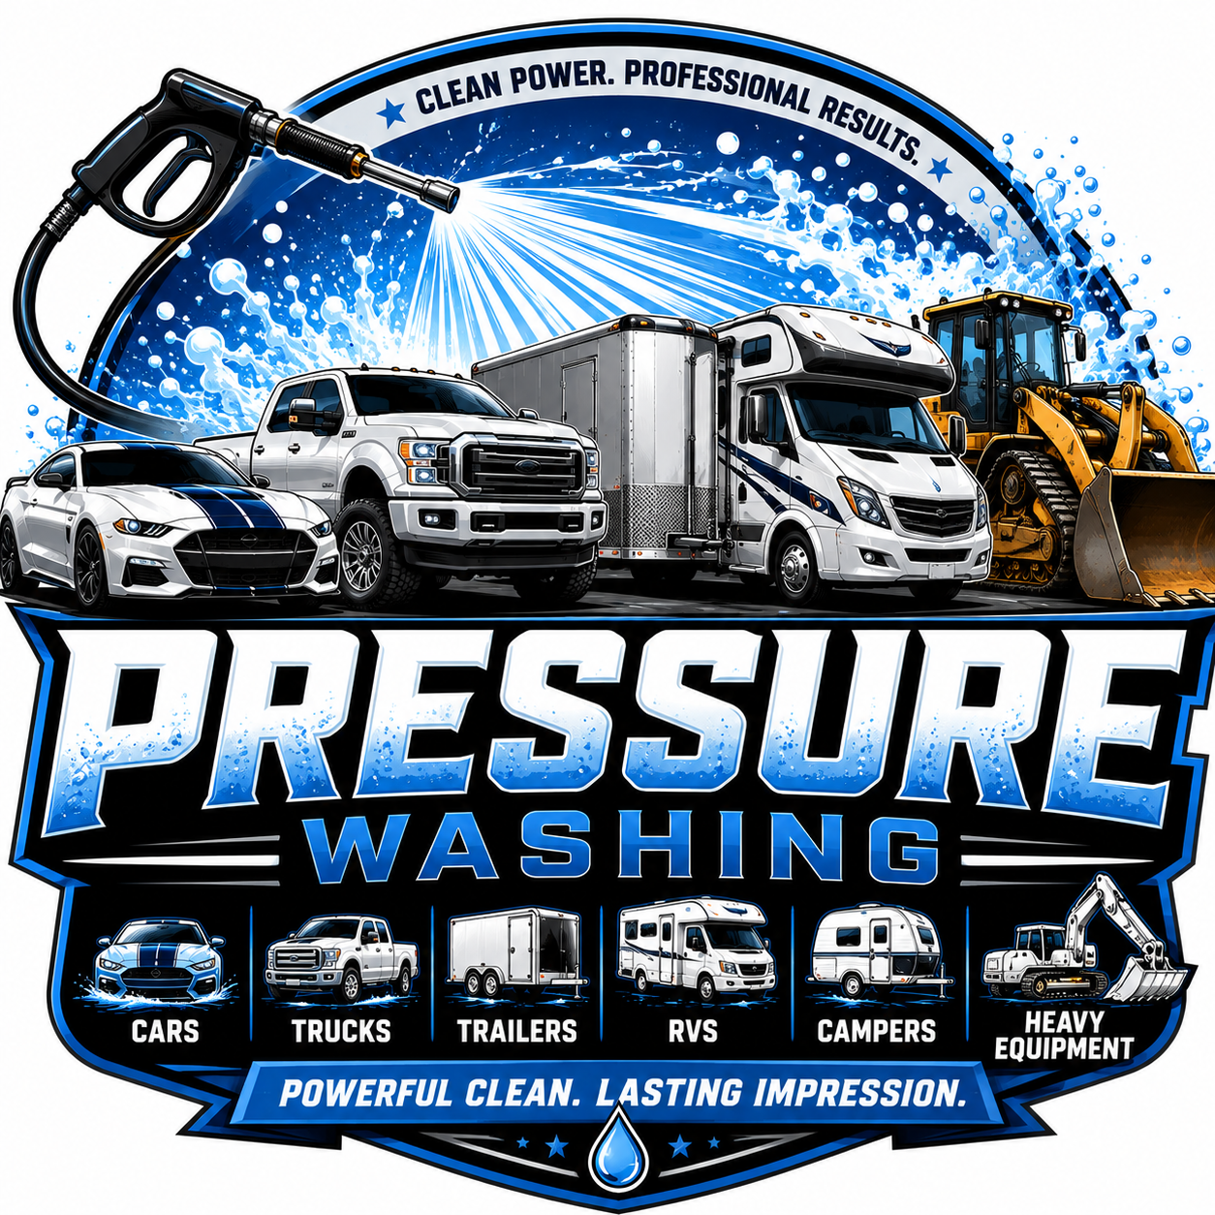
Services
Auto detailing (interior and exterior) Exterior Home Wash RV/Camper Wash
Car waxing / Ceramic coating Fleet Spot free rinse Residential Commercial Pressure Washing Full body exterior wash Semi-Truck Wash
Driveway Cleaning Heavy Equipment wash Wheel Wash & Shine

